String and File attributes

1) Explore some more attributes

-r

-x

-o

Filrattr.sh

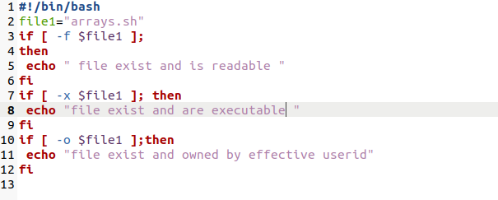

Terminal

